Chapter 9 - Light - Reflection and Refraction
Solutions Key · Class X CBSE Physics
Solutions are grouped section-wise and follow the same numbering and tier order as the worksheet. Full working with units is shown for every numerical.
Section A. General Questions
1. Define the principal focus of a concave mirror.
The principal focus (F) of a concave mirror is the point on the principal axis at which rays of light coming parallel to the axis meet (converge) after reflection from the mirror.
2. State the two laws of reflection of light.
(1) The angle of incidence is equal to the angle of reflection (∠i = ∠r).
(2) The incident ray, the reflected ray and the normal at the point of incidence all lie in the same plane.
3. Radius of curvature 20 cm — find the focal length.
Using $f = \frac{R}{2}$ → f = 20/2 = 10 cm.
4. Mirror used (a) as a rear-view mirror, (b) as a torch/searchlight reflector.
(a) A convex mirror (erect, diminished image with a wide field of view).
(b) A concave mirror (a source at its focus gives a strong parallel beam).
5. Define the refractive index of a medium.
The refractive index of a medium is the ratio of the speed of light in vacuum (c) to the speed of light in that medium (v): $n = \frac{c}{v}$.
6. State Snell's law of refraction.
For a given pair of media, the ratio of the sine of the angle of incidence to the sine of the angle of refraction is constant and equals the refractive index: $\frac{sin i}{sin r} = n_{21}$.
7. SI unit of power of a lens; define one dioptre.
The SI unit of power is the dioptre (D). One dioptre is the power of a lens whose focal length is 1 metre (1 D = 1 m⁻¹).
8. Refractive index of diamond is 2.42 — meaning?
It means light travels 2.42 times faster in vacuum than in diamond. So $v = \frac{c}{2.42} = \frac{3 × 10⁸}{2.42}$ ≈ 1.24 × 10⁸ m/s.
9. Mirror and lens that always give a virtual, erect, diminished image.
A convex mirror and a concave lens.
10. Air → water: does the ray bend towards or away from the normal? Why?
It bends towards the normal, because water is optically denser than air, so light slows down on entering it and bends towards the normal.
11. A lens of focal length −20 cm — type and power.
A negative focal length means it is a concave (diverging) lens. $P = \frac{1}{f (m)} = \frac{1}{−0.20}$ = −5 D.
12. When does a concave mirror form an image of the same size as the object?
When the object is placed at the centre of curvature (C). The image is then also at C — real, inverted and the same size as the object.
13. Why does the mirror formula have a plus sign but the lens formula a minus sign?
It follows from the New Cartesian sign convention. In a mirror the light is reflected, so a real image forms on the same side as the object; in a lens the light is refracted through it, so a real image forms on the opposite side. Applying the convention to each geometry gives 1/v + 1/u = 1/f for mirrors and 1/v − 1/u = 1/f for lenses.
Section B. Multiple Choice Questions
14. Angle of incidence 30° — angle between incident and reflected ray.
Answer: (b) 60°. The reflected ray also makes 30° with the normal, so the two rays are 30° + 30° = 60° apart.
15. Focal length for radius of curvature 30 cm.
Answer: (b) 15 cm (f = R/2 = 30/2).
16. Which makes a parallel beam from a point source?
Answer: (a) Concave mirror as well as convex lens. A source at the focus of a concave mirror or a convex lens gives a parallel beam.
17. Which forms a virtual, erect image for every object position?
Answer: (c) Concave lens. A concave lens always forms a virtual, erect, diminished image.
18. Magnification produced by a convex mirror is always…
Answer: (b) less than 1. The image is always diminished (and erect, so m is positive but < 1).
19. Awl-pin problem — focal length of the concave mirror.
h = 10 mm, h′ = 5 mm (real, inverted → m = −0.5), v = −30 cm.
m = −v/u → −0.5 = −(−30)/u → u = −60 cm.
1/f = 1/v + 1/u = −1/30 − 1/60 = −1/20 → f = −20 cm.
Answer: (b) −20 cm.
20. When does a concave mirror form an image larger than the object?
Answer: (c) When the object is between the focus and the centre of curvature.
21. Speed of light 2 × 10⁸ m/s — refractive index.
Answer: (a) 1.5 (n = c/v = 3 × 10⁸ / 2 × 10⁸).
22. Object at the focus of a convex lens — image is formed…
Answer: (b) at infinity.
23. Focal length of a lens of power +2.5 D.
Answer: (b) 40 cm (f = 1/P = 1/2.5 = 0.4 m).
24. Emergent ray from a rectangular glass slab.
Answer: (b) parallel to the incident ray (laterally displaced).
25. Convex lens forms a real, inverted, same-size image when the object is at…
Answer: (b) 2F.
26. Concave lens f = 15 cm, image 10 cm from lens — object distance.
f = −15 cm, v = −10 cm. 1/u = 1/v − 1/f = −1/10 + 1/15 = −1/30 → u = −30 cm.
Answer: (a) −30 cm.
27. Object moved from beyond 2F₁ towards 2F₁ of a convex lens — the real image…
Answer: (a) moves away from the lens and enlarges.
28. Power of a combination of +5 D and −2 D in contact.
Answer: (a) +3 D. Powers add with their signs: P = +5 + (−2) = +3 D.
29. Radius of curvature of a plane mirror.
Answer: (b) infinity. A plane mirror is a spherical mirror of infinite radius of curvature.
Section C. Assertion - Reason
30. A: Convex mirror preferred as rear-view mirror. R: gives erect, diminished image with wider field of view.
Answer: (a). Both are true and R correctly explains why a convex mirror is chosen.
31. A: Light travels faster in water than in vacuum. R: Refractive index of water is 1.33.
Answer: (d). A is false (light is slower in water than in vacuum); R is true.
32. A: A concave lens always forms a virtual image. R: A concave lens diverges the light.
Answer: (a). Both true; divergence is exactly why the image is always virtual and erect.
33. A: A ray entering a slab along the normal does not bend. R: If i = 0°, then r = 0°.
Answer: (a). Both true and R is the correct explanation.
34. A: A concave mirror can form both real and virtual images. R: The nature depends on the object position.
Answer: (a). Both true; the object position decides whether the image is real or virtual.
Section D. Theory and Numerical Problems
35. State the rules used to locate the image formed by a spherical mirror.
Any two of the following reflected rays locate the image:
(1) A ray parallel to the principal axis passes through the focus F after reflection.
(2) A ray passing through F becomes parallel to the principal axis after reflection.
(3) A ray through the centre of curvature C retraces its path (strikes normally).
(4) A ray striking the pole P reflects making equal angles with the principal axis.
36. Ray diagrams for a concave mirror: object (a) at C, (b) between F and P.
(a) Object at C → image at C: real, inverted, same size.
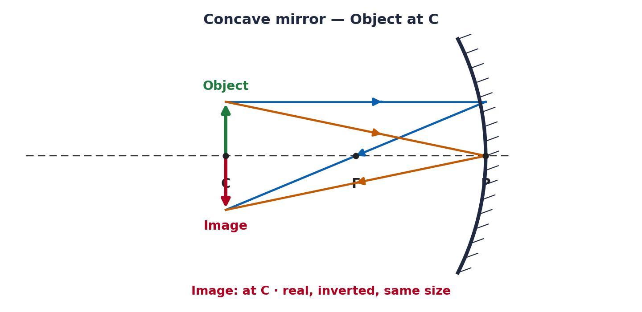
(b) Object between F and P → image behind the mirror: virtual, erect, enlarged.
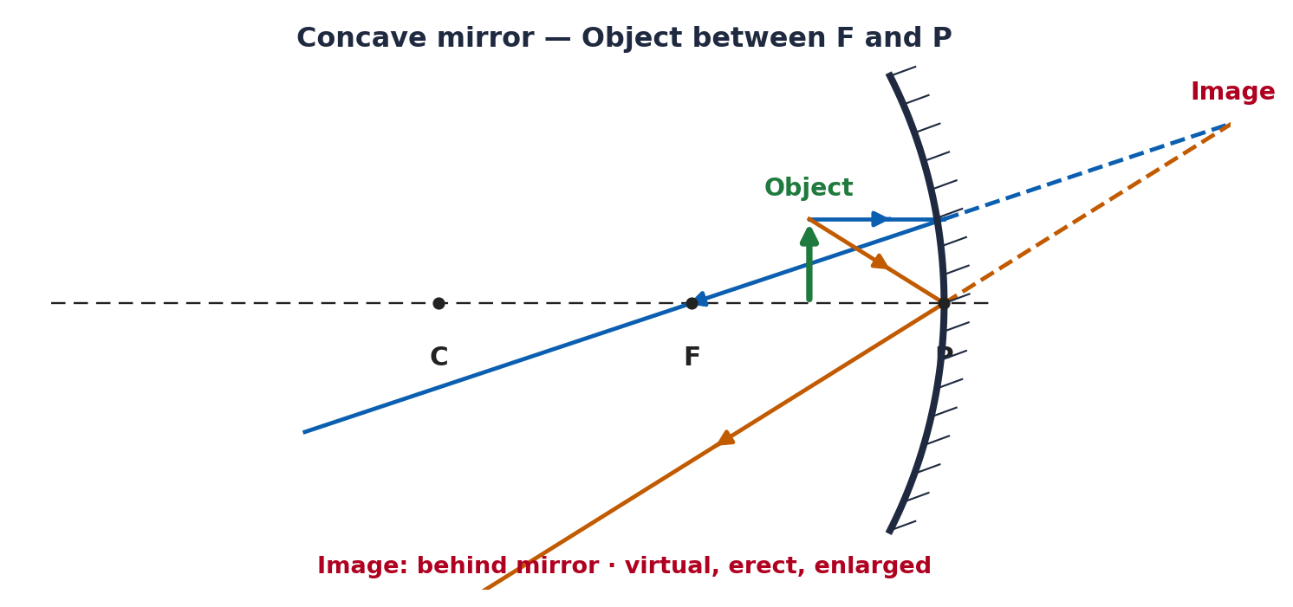
37. Object 4 cm high, 20 cm from a concave mirror of focal length 15 cm — position, size, nature.
u = −20 cm, f = −15 cm, h = 4 cm.
1/v = 1/f − 1/u = −1/15 + 1/20 = −1/60 → v = −60 cm.
m = −v/u = −(−60)/(−20) = −3 → h′ = m·h = −12 cm.
The image is 60 cm in front of the mirror, real, inverted and enlarged (12 cm tall).
38. Concave mirror forms a real image 3× the object placed 10 cm in front — image position and focal length.
Real, inverted image → m = −3, u = −10 cm.
m = −v/u → −3 = −v/(−10) → v = −30 cm.
1/f = 1/v + 1/u = −1/30 − 1/10 = −4/30 → f = −7.5 cm.
Image is 30 cm in front of the mirror; focal length is 7.5 cm.
39. Labelled ray diagram — refraction through a rectangular glass slab.
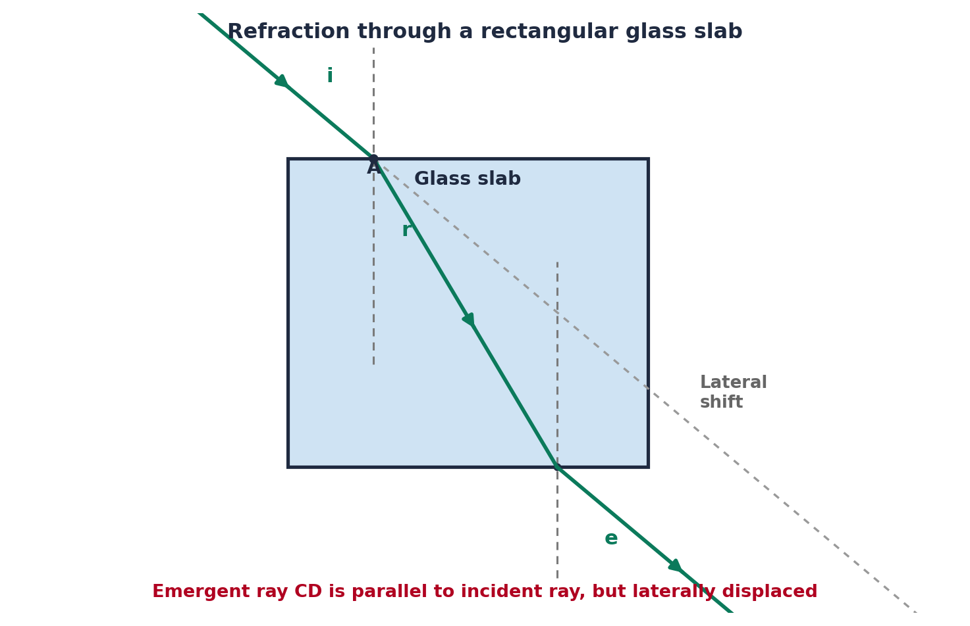
The ray bends towards the normal on entering the denser glass and away from the normal on leaving. The emergent ray is parallel to the incident ray and shifted sideways by the lateral displacement.
40. Speed of light in glass of refractive index 1.5 (c = 3 × 10⁸ m/s).
v = c/n = (3 × 10⁸)/1.5 = 2 × 10⁸ m/s.
41. Object 25 cm from a convex lens of focal length 10 cm — image distance and magnification.
u = −25 cm, f = +10 cm.
1/v = 1/f + 1/u = 1/10 − 1/25 = 3/50 → v = +16.7 cm.
m = v/u = 16.7/(−25) = −0.67. Real, inverted, diminished image.
42. State the laws of refraction; explain absolute refractive index.
Laws: (1) the incident ray, refracted ray and normal lie in the same plane; (2) sin i / sin r = constant (Snell's law).
Absolute refractive index of a medium is its refractive index with respect to vacuum: $n = \frac{c}{v}$ — the ratio of the speed of light in vacuum to that in the medium.
43. Ray diagrams for a convex lens: object (a) beyond 2F₁, (b) between F₁ and O.
(a) Object beyond 2F₁ → image between F₂ and 2F₂: real, inverted, diminished.
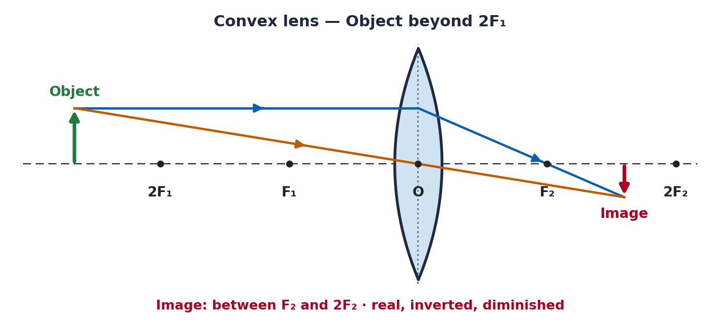
(b) Object between F₁ and O → image on the same side: virtual, erect, enlarged.
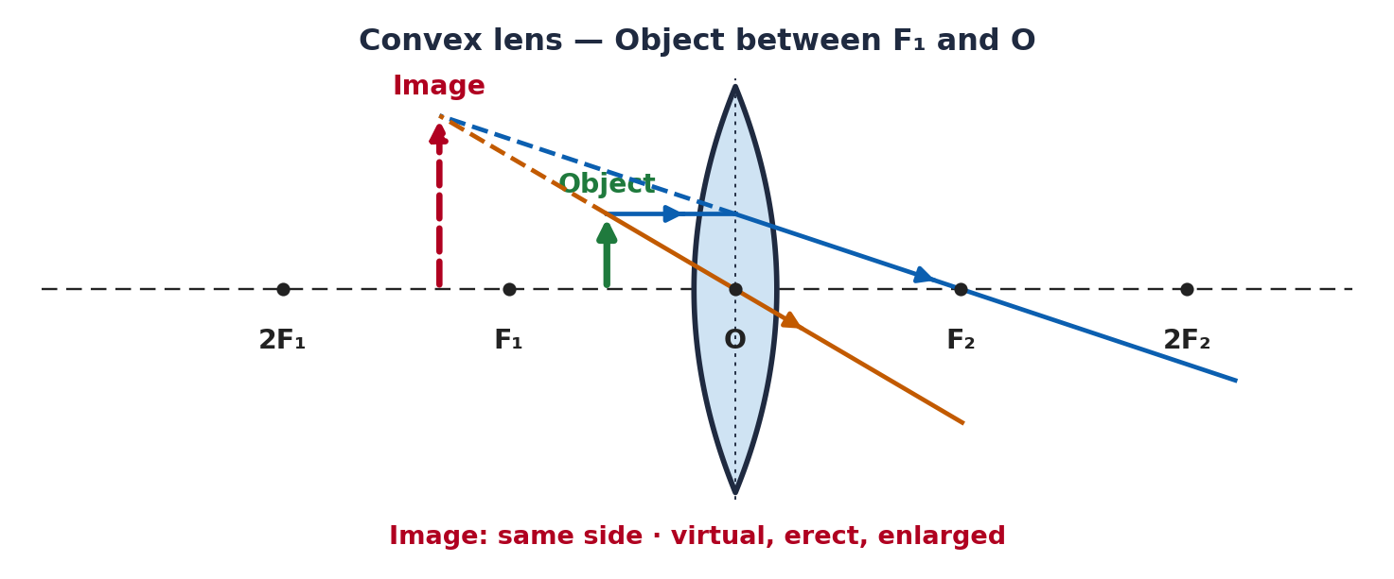
44. Image real, inverted, m = −1, image 40 cm from the lens — focal length, object distance, type.
m = −1 → v = −u; real image → v = +40 cm, so u = −40 cm.
1/f = 1/v − 1/u = 1/40 + 1/40 = 1/20 → f = +20 cm.
It is a convex lens; the object is at 2F (40 cm).
45. Object 10 cm from (i) a concave mirror and (ii) a convex lens, each f = 15 cm — compare.
(i) Concave mirror: u = −10 cm, f = −15 cm.
1/v = 1/f − 1/u = −1/15 + 1/10 = 1/30 → v = +30 cm; m = −v/u = +3.
Image 30 cm behind the mirror — virtual, erect, enlarged (3×).
(ii) Convex lens: u = −10 cm, f = +15 cm.
1/v = 1/f + 1/u = 1/15 − 1/10 = −1/30 → v = −30 cm; m = v/u = +3.
Image 30 cm on the same side as the object — virtual, erect, enlarged (3×).
Comparison: both give a virtual, erect, 3× image; the mirror's image is behind the mirror while the lens's image is on the object's side.
46. 5 cm object, 30 cm from a convex lens of focal length 20 cm — position, size, nature.
u = −30 cm, f = +20 cm, h = 5 cm.
1/v = 1/f + 1/u = 1/20 − 1/30 = 1/60 → v = +60 cm.
m = v/u = 60/(−30) = −2 → h′ = −10 cm.
Image 60 cm on the other side of the lens — real, inverted, enlarged (10 cm tall).
47. Show that R = 2f for a concave mirror using a ray parallel to the axis.
A ray parallel to the principal axis strikes the mirror at point M and reflects through F. The normal at M passes through C, so ∠(incident, normal) = ∠(reflected, normal). For a small aperture, triangle MFC is isosceles with FM = FC, and F is the midpoint of PC. Hence PF = ½ PC, i.e. f = R/2, or R = 2f.
48. A convex lens of focal length f is cut in two along the principal axis — focal length of each half?
Each half still has the same two surface curvatures as the original lens, so by the lens-maker's relation the focal length is unchanged — each half is still a lens of focal length f. (A common trap is to think it doubles or halves.)
49. A glass rod seems to disappear in a liquid — explain.
The liquid has the same refractive index as the glass. At the glass–liquid boundary there is then no change in optical density, so light is neither refracted nor reflected there; the rod becomes indistinguishable from the liquid and appears to vanish.
50. Using the mirror formula, show a convex mirror always forms a virtual image.
For a convex mirror f is +ve and the object is real (u −ve). 1/v = 1/f − 1/u = 1/f + 1/|u|, which is always positive, so v is always +ve.
A positive v means the image is always behind the mirror — i.e. always virtual (and erect, diminished), whatever the object position.
51. Convex (+5 D) and concave (−2 D) lenses in contact; object 40 cm away — power and image position.
Combined power P = +5 + (−2) = +3 D → f = 1/P = 1/3 m = +33.3 cm.
u = −0.4 m: 1/v = P + 1/u = 3 + (−2.5) = 0.5 → v = +2 m (200 cm).
m = v/u = 2/(−0.4) = −5. Real, inverted, enlarged image 2 m from the combination.
Section E. Case Study - Based Questions
52. Rear-view mirror case study.
(i) A convex mirror — it gives an erect image and a much wider field of view.
(ii) The image is virtual, erect and diminished.
(iii) f = R/2 = 3/2 = 1.5 m.
(iv) Distances (and sizes) appear smaller than they really are, so the driver can misjudge how far away a following vehicle is.
53. Pencil-in-water case study.
(i) Refraction of light.
(ii) Water is optically denser than air.
(iii) Going from water (denser) to air (rarer), the ray bends away from the normal.
(iv) $n = \frac{c}{v}$ — refractive index equals the ratio of the speed of light in vacuum to that in the medium.
54. Magnifying-glass case study.
(i) A convex (converging) lens.
(ii) When the object is within the focal length, the image is virtual, erect and enlarged, on the same side as the object.
(iii) u = −5 cm, f = +10 cm:
1/v = 1/f + 1/u = 1/10 − 1/5 = −1/10 → v = −10 cm; m = v/u = +2.
So a virtual, erect, 2× image is formed 10 cm from the lens on the object's side.
(iv) Ray diagram:


